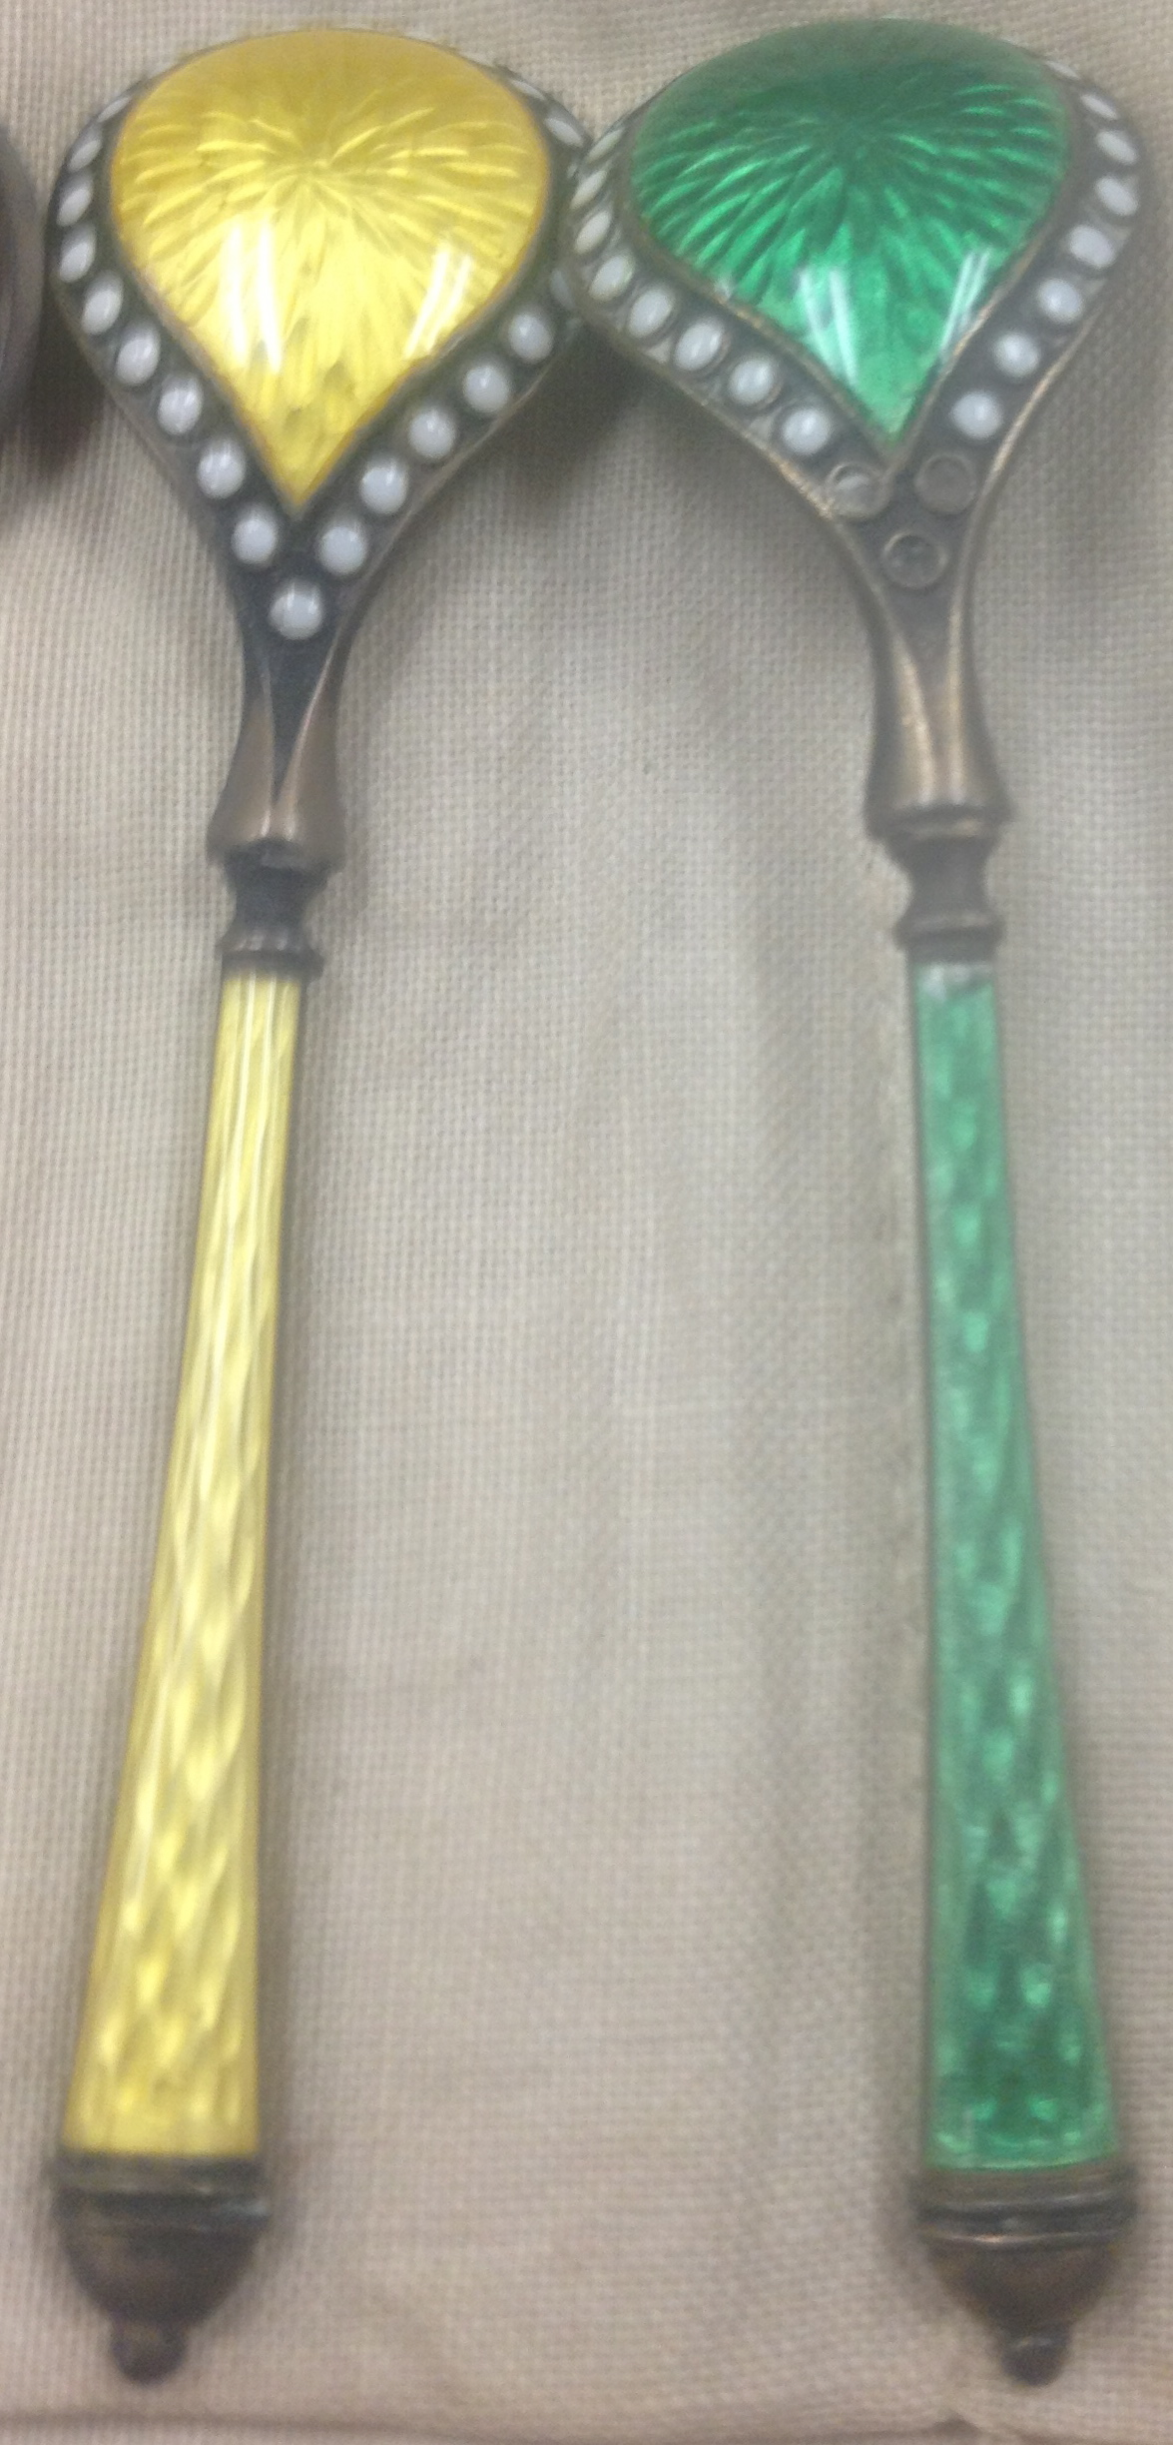
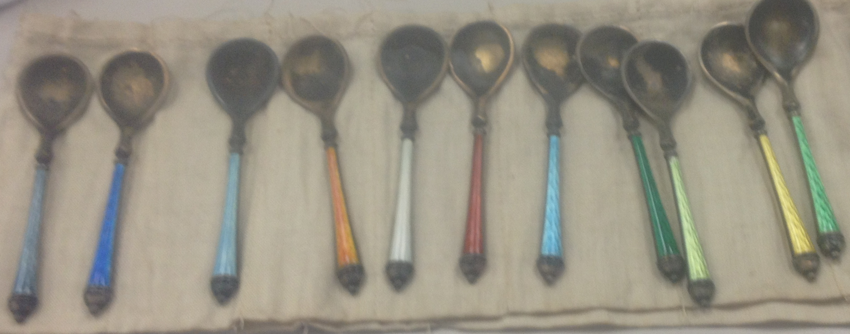
Norwegian Salt Spoons c.1920 (approx.)
Sterling Silver with colored enamel inlay decoration
Unidentified maker
According to various etiquette books written from the 1920s-60s, salt spoons were most commonly reserved for use at both formal and informal dinner parties. Partygoers would either share a set of salt and pepper dispensers with their closest neighbor or each had a separate spoon to use to take salt from a communal dish. In her Complete Book of Etiquette, Amy Vanderbilt stated, “open salts and peppers require little sterling, ivory, or mother of pearl spoons” (349). The set of salt spoons in the museum collection are made of sterling silver as recognized by the “925” printed on the right side handle on the front of the spoon. Historically, the “925” mark was used by English silver makers to delineate their use of 92.5% silver, but starting in 1920, Norwegian silver makers began using 92.5% as well as continuing their use of 83% silver. Printed on the left side of the handle is the maker’s mark, which is still in the process of being identified. The enameled inlaid designs on the front and back of the handle and on the back of the bowl are what distinguished the spoons as Norwegian in style. Also, the shape of the bowl is unique as most salt spoon bowls are typically shell or shovel shaped and not leaf shaped. Note the discol orations on the bowls from salt residue and the three pieces of missing enamel inlay on the back of the lighter green spoon.
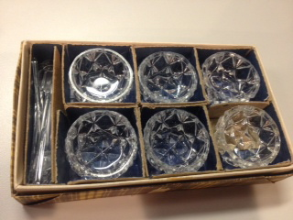

Salt Serving set
Lead Glass with cut decoration
Unidentified maker
Another salt serving set of both spoons and cellars in the museum’s collection, is made out of colorless lead glass. The spoons have shovel shaped bowls with little to no surface decoration. The salt cellar has diamond shaped geometric patterns cut around the bowl as well as a four pointed star design cut on the bottom.

Stiegel Pocket Bottle
This piece of glassware is an amethyst colored pocket bottle dating to the late eighteenth or early nineteenth century. The combination of the bottle’s deep purple color, its rounded shape, and its Diamond-Daisy pattern were characteristics typical of bottles manufactured in Pennsylvania during this time. Although it is difficult to associate this bottle with a particular maker, amethyst pocket bottles containing this diamond pattern were often attributed to Henry William Stiegel, who operated a glassblowing company in Manheim, Pennsylvania from 1764 to 1775.
During its manufacture, the glass was blown into a partial-sized mold that imprinted the Diamond-Daisy pattern on the exterior of the bottle. Afterwards, the glass underwent additional blowing and shaping to create the bottle’s final form, a process that slightly distorted the molded design. Bottles of a similar shape and design were typically intended to hold medicinal or alcoholic liquids, and their small size allowed individuals to easily transport the liquids in small quantities. Within the broader context of eighteenth century bottles, this piece certainly stands out for its visually appealing color and design.

Krill, Rosemary Troy. Early American Decorative Arts: 1620-1860: A Handbook for Interpreters. AltaMira Press, 2001. Pp. 145.
Krill, Rosemary Troy. Early American Decorative Arts: 1620-1860: A Handbook for Interpreters. AltaMira Press, 2001. Pp. 150.
Van Rensselaer, Stephen. Early American Bottles and Flasks. Peterborough: Transcript Printing Company, 1926. Pp. 49.

